# STATE BICYCLE AND PEDESTRIAN COORDINATOR

### [Name(s)]

*[Placeholder for logo, ex. State DOT logo if permitted]*

### [Position Title(s)]

### [Email(s)]

### [Phone number(s)]

**The role of the bicycle and pedestrian coordinator was institutionalized by the Intermodal Surface Transportation Efficiency Act (ISTEA). This act, passed by Congress in 1991, requires that every U.S. State employs a bicycle and pedestrian coordinator within their State Department of Transportation (DOT). State DOTs fill this position in a variety of ways- some states have one coordinator, and some split responsibilities across two or more positions. *[Placeholder to insert any specific laws or policies that state has that support the role/requirement for coordinator position]*. In *[insert state here], [insert info how position is staffed and where within the DOT the coordinator is housed].*

[Replace graphic above with an image of a project coordinator has worked on, replace this caption with caption and source]

## Roles, Responsibilities, and Goals

While the roles, responsibilities, and goals of State bicycle and pedestrian coordinators differ by State, coordinators generally strive to improve the safety of and opportunities for active transportation users. This may include pedestrians, cyclists, those who use micromobility, those who use personal assistive devices, and transit riders. Specific roles and responsibilities for coordinators may include:

*[Choose example responsibilities applicable to your role to update and personalize. Add new items relevant for your State as needed:]*

* Serve as the subject matter expert on bicycle/pedestrian infrastructure
* Serve on and facilitate committees and working groups relating to walking and cycling
* Advocate for the prioritization of active transportation
* Institutionalize active transportation within government policy
* Create and update plans
* Liaise between departments and agencies, both internal and external
* Create and manage robust data management programs
* Administer active transportation grant programs
* Improve public perceptions of active transportation
* Provide education and outreach relating to active transportation
* Connect local communities to funding and other resources to improve active transportation
* *[Add new items relevant to your position or State as needed:]*

Project Showcase

*[Choose a project you have worked on that represents your work, and describe it in this section]* Lorem ipsum dolor sit amet, consectetur adipiscing elit, sed do eiusmod tempor incididunt ut labore et dolore magna aliqua. In iaculis nunc sed augue lacus viverra vitae. Vulputate sapien nec sagittis aliquam malesuada. Posuere urna nec tincidunt praesent. Congue nisi vitae suscipit tellus mauris. In fermentum posuere urna nec tincidunt praesent. Velit scelerisque in dictum non. Magnis dis parturient montes nascetur. Posuere lorem ipsum dolor sit amet consectetur. Eget aliquet nibh praesent tristique. Dignissim suspendisse in est ante in nibh mauris. Condimentum id venenatis a condimentum vitae sapien pellentesque. Tellus in hac habitasse platea dictumst.

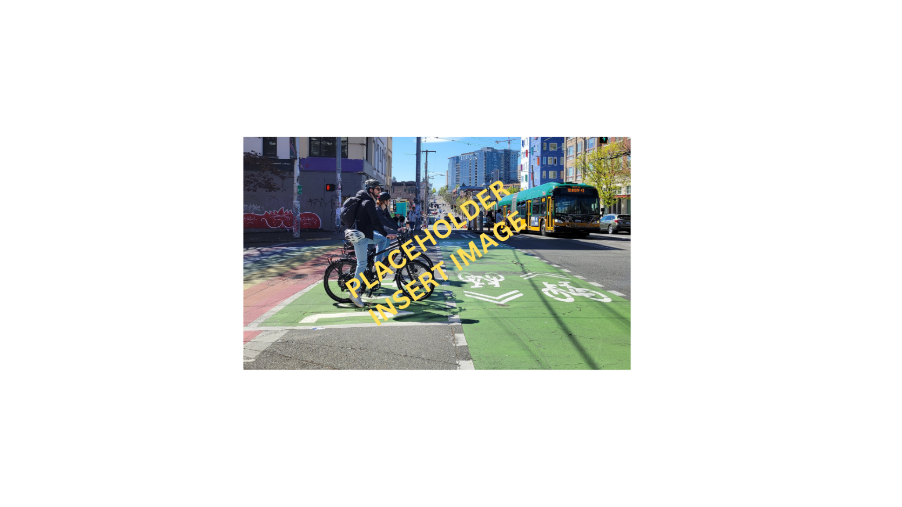Facilisis magna etiam tempor orci eu lobortis elementum nibh. Eget sit amet tellus cras adipiscing enim. Eros donec ac odio tempor orci dapibus ultrices. Adipiscing commodo elit at imperdiet dui accumsan sit amet nulla. Pellentesque pulvinar pellentesque habitant morbi tristique senectus et netus et.

[Replace graphic above with an image of a project coordinator has worked on, replace this caption with caption and source for the image]

[Replace graphic above with an image of a project coordinator has worked on, replace this caption with caption and source for the image]

## Support for Coordinators

Coordinators receive support and resources from the Pedestrian and Bicycle Information Center (PBIC), which is supported and funded by the U.S. Department of Transportation Federal Highway Administration. PBIC facilitates bimonthly meetings for all coordinators, an email listserv for coordinators to share ideas, and online technical resources that can be shared with communities.

## How You Can Support Your State Coordinator(s)

As funding for active transportation steadily increases, it is important to understand how to best support coordinators in your state in working towards statewide active transportation goals. Coordinators need support from elected officials and leadership in their DOTs to move past some of the major challenges they face. Support from higher-ups can include utilizing interagency connections and relationships to support collaboration, creating technical working groups for issues relating to active transportation, and being intentional about where within the DOT structure the coordinators are housed.